|  |
| --- |
| **GVC #3—I can identify and explain how the structure of DNA relates to its function.** |
| **Learning Target – c. I can apply principles of DNA Transcription and Translation to synthesize a protein**. |

**Book Notes – Transcription and Translation**

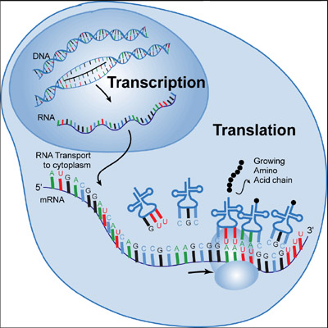**p. 145-148**

# DNA vs. RNA (p. 146)

DNA RNA

1. 1.

2. 2.

# Complete the Base Pairs (p. 146)

# DNA RNA

1. A - _____, G - ______ 21. A - ______, G - ______

1. Complete the matching strand of mRNA

DNA Strand: A A T G C A C T G G A

RNA Strand:

1. Making an exact copy DNA is called ________________ (p. 145)
2. Changing DNA into mRNA is called _________________ (p. 146)
3. Changing mRNA into proteins is called ________________ (p. 146)
4. _________________________ are the monomers of proteins. They bond together to form a protein. (p. 146)
5. Transcription happens in the ________________, while translation happens in the _____________.
6. The organelles that read the mRNA code to make proteins are called ____________________.
7. Which type of RNA:
   1. Is a copy of a segment of DNA _____________
   2. Brings amino acids to the ribosome ____________
8. The three letter bases of mRNA that code for one amino acid are called __________. (p. 146)
9. How does a strand of DNA code for a trait:

**Trait**

TRANSLATION

**RNA**

**DNA**

12. Use the chart to determine what amino acid would be coded by the following groups of **mRNA** codons

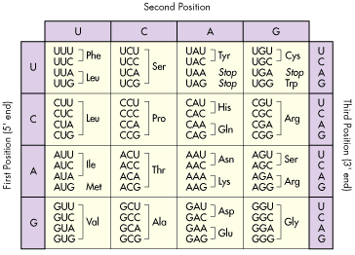

* 1. ACA _______________
  2. CCG _______________
  3. CAC _______________
  4. GGG _______________
  5. CGG _______________
  6. CUG _______________
  7. GUG _______________
  8. UGG _______________
  9. UAA _______________
  10. CUU _______________