Super Powered Genetics
Scientists have been investigating the genetics of the offspring of several famous superheroes. Use the information given and your knowledge of genetics to answer the following questions.
- For each genotype listed below, indicate whether it is Homozygous (Ho) or Heterozygous (He).
TT______ Bb_______ DD_______ Ff_______ tt______ dd_____
Dd______ Ff________ tt_________ bb_______ BB_____ FF_____

- For the genotypes listed above, which ones would be considered Purebred? _____________________

- For the genotypes listed above, which ones would be considered Hybrid? ______________________

- Beast from the X-Men has a version of the skin color allele that turns his skin blue. Another version of the allele results in green skin color instead of blue. However, the blue body color allele (B) is dominant to green.

Below are the possible genotypes for this skin color allele, determine the phenotype for each of the genotypes listed below, circle the genotypes that are possible for Beast:

BB________________ Bb________________ bb________________

- Mystique also has this skin color variation. She and Beast are both heterozygous. If Beast and Mystique were to have children, draw the Punnett Square to show the possible genotypes of their children and answer the following questions:

  - What are the chances of a child with blue skin?
______ out of ______ or _______%
  - What are the chances of a child with green skin?

______ out of ______ or _______%

- Superman’s laser and x-ray vision abilities are due to a recessive allele (v). The dominant allele (V) leads to normal vision. Lois Lane is heterozygous for this gene. Draw the Punnett Square to determine if any of their children might have super-powered vision and answer the following questions:
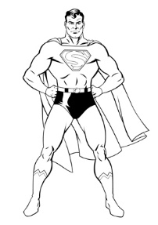
  - What are the chances of a child with normal vision?
______ out of ______ or _______%
  - What are the chances of a child with superpowered vision?

______ out of ______ or _______%

- On Krypton, super-speed is a dominant trait. Superman’s cousin, Supergirl is Homozygous dominant for the allele that causes super-speed, she has a child with a Kryptonian who is heterozygous for this trait. Draw the Punnett Square to show the possible genotypes for their child.

  - What chance does their child have for developing super-speed?

  - What chance does their child have of not developing super-speed?

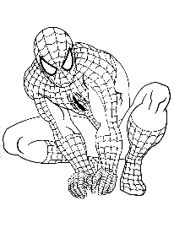
- Peter Parker (a.k.a. Spiderman) recently found out that he was able to develop superpowers from a radioactive spider bite because he is Purebred for the “spider bite” allele. However, only the recessive form of this allele allows a person to develop superpowers from spider bites. When Peter marries Mary Jane Watson, they discover that she is homozygous dominant for this gene.

  - What percentage of their children will be able to develop superpowers from radioactive spiders?

  - What percentage of their children will be Purebred?

  - What percentage of their children will be considered hybrid?

- Wonder Woman gets her superhuman strength because of a dominant version of the super strength gene. One day a man shows up claiming to be her long-lost biological brother. He does not have super strength, but he claims that he just inherited a different version of that gene. Wonder Woman knows that her father is homozygous dominant for the super strength gene and her mother is heterozygous.

  - Draw the Punnett Square for Wonder Woman’s parents

  - What percent of the children (Wonder Woman and her siblings) should have super strength?

  - Could this man be her brother? How do you know?

