Solutions Practice Problems
Formulas to remember:
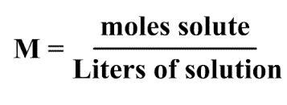
Molarity: Diluting a Solution: (M1)(V1) = (M2)(V2)

- Calculate the molarity of a solution that has 2.3 moles of sodium chloride in 0.45 liters of water.

- What is the molarity if I dissolve 0.75 moles of lithium fluoride in 65mL of water?

- Calculate the amount in grams of Ca(NO3)2 (calcium nitrate) needed to make a 3M solution with 750mL of water.

- What would the concentration of a solution containing 45 grams of ammonia (NH3) in 125 mL of water?

- If you had a known solution of hydrochloric acid (12M) and needed to dilute it down to make 750ml of a 0.5M solution, how many mL of the 12M acid would you need?

- If you have a beaker containing 350 mL of a 6M solution of NaOH and need to dilute it down to a 1.5 M solution, how much water should you add to the beaker?

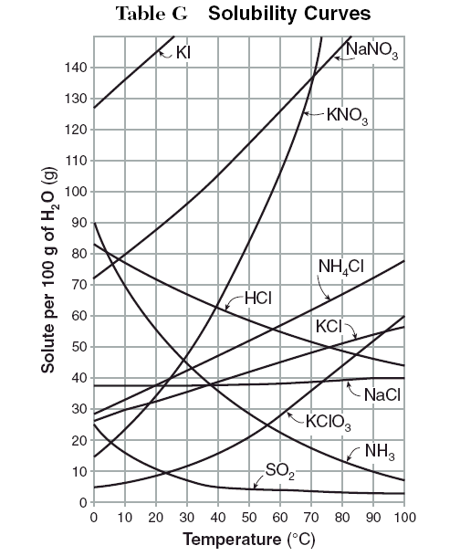
Solubility Curves
- Given the solubility curve to the right, how much KClO3 could be dissolved at 50⁰ C?

- What salt is the least soluble at 100⁰C?

- If you dissolved 55g of KNO3 in 100g of water at 60⁰C, would this solution be unsaturated, saturated, or supersaturated?

- If you tried to dissolve 85 grams of NH3 in 100g of water at 10⁰C, how much salt would remain undissolved?
- Use the data below to create a solubility curve for sugar:

Temperature (⁰C) | Amount dissolved / 100g of water
5º | 180g
20º | 200g
50ºC | 253g
75ºC | 339g
100ºC | 473g

- List 3 ways you could get a solute to dissolve faster in a solvent.

Colligative Properties

- If salt is added to a flask of water, the freezing point of that water should ______________________ (increase, decrease, stay the same).

- If two beakers of salt water were placed into a freezer, one that had 20 grams of salt and the other had 80 grams of salt, which would you expect to freeze first? Explain why.

- Explain why adding salt to boiling water helps noodles boil faster.

