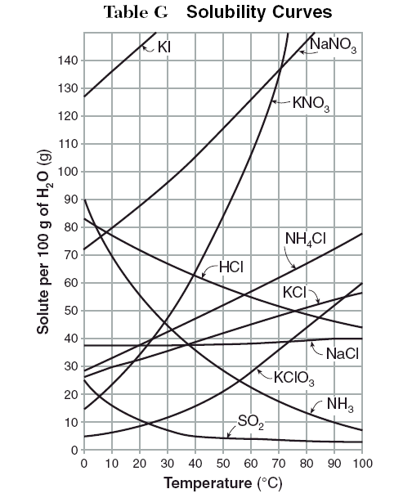
Solubility Curves - Practice
- Given the solubility curve to the right, how much KClO3 could be dissolved at 50⁰ C?

- What salt is the least soluble at 100⁰C?

- If you dissolved 55g of KNO3 in 100g of water at 60⁰C, would this solution be unsaturated, saturated, or supersaturated?

- If you tried to dissolve 85 grams of NH3 in 100g of water at 10⁰C, how much salt would remain undissolved?

Solubility Curves - Practice
- Given the solubility curve to the right, how much KClO3 could be dissolved at 50⁰ C?

- What salt is the least soluble at 100⁰C?

- If you dissolved 55g of KNO3 in 100g of water at 60⁰C, would this solution be unsaturated, saturated, or supersaturated?

- If you tried to dissolve 85 grams of NH3 in 100g of water at 10⁰C, how much salt would remain undissolved?

