Genetics Review:
The following topics will be on your upcoming test. There are practice problems that demonstrate the type of questions you will be asked on your test so make sure you review your notes, vocabulary sheets, and any other resources to prepare yourself. Good Luck!

Vocabulary to be familiar with:

Dominant
Co-Dominance
Recessive
Sex-linked
Homozygous
Polygenic traits
Heterozygous
Pedigree
Phenotype
Carrier
Genotype
Law of Segregation
Gregor Mende l
Law of Independent Assortment
Incomplete Dominance
Selective Breeding
Transcription
Translation
RNA/DNA

Make sure you understand how to set up and interpret a Punnett square, you will also have to analyze pedigree charts and interpret inheritance patterns. For this section, it is crucial that you understand your vocabulary terms!

Practice Problems:
- In certain species of snakes, large scales (S) are dominant to small scales (s). A snake that is heterozygous for the trait is crossed with a snake that has small scales. What would the expected phenotypes be for the offspring?

- 50% large scales, 50% small scales
- 50% Ss, 50% ss
- 50% Ss, 50% SS
- 25% small scales, 75% large scales

- A father is homozygous dominant for a particular trait. If his spouse is homozygous recessive for the same trait, what is the probability that their offspring will have the homozygous dominant genotype?

- 0
- 1/2
- 1/4
- 3/4

- In snapdragon flowers, red color (BB) is incompletely dominant over white flowers (WW). The heterozygous condition produces pink flowers (BW). In a cross between a white colored flower and a pink flower, what percentage of the offspring will have pink flowers?

- 0%
- 25%
- 50%
- 100%

- Which of the following is the correct genotype for females?

- XY
- XX
- XO
- X

- In horses, a red coat is co-dominant to a white coat. When a horse is heterozygous for this trait it has both red and white hair which is called a roan coat. If a roan horse was bred with a horse with a red coat, what are the genotypic and phenotypic frequencies that could result?

- Hemophilia is a recessive, sex-linked disease (X^{h}). If a woman is heterozygous (X^{h}X^{H}), she will be a carrier for the disease, but will not have hemophilia. If a woman who is a carrier for hemophilia marries a man that does not have hemophilia, how many of the offspring would have hemophilia?

Use the pedigree chart to answer questions 7-12:
Individuals that are shaded in have the condition Tay-Sachs which is inherited through a homozygous recessive genotype. Go through the pedigree and write in the probable genotypes for each individual and then answer 6-11:

- How many generations are shown in this pedigree?

- How is individual #16 related to #2?

- How many children did individual #11 have?
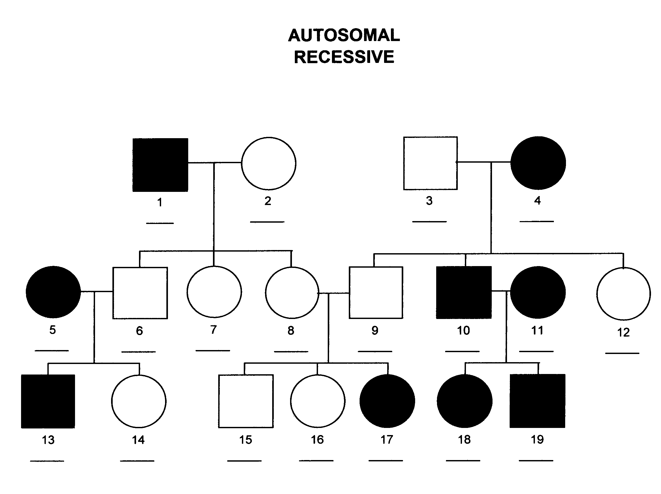
- What is the genotype of individual #6?

- What are the genotypes of individuals #8 and #9 based on the information in the pedigree?

- If #14 mated with an individual that is homozygous dominant for the trait, what percent of their offspring would have Tay-Sachs?

DNA and Protein Synthesis:
Make sure you understand the differences between DNA and RNA as well as how proteins are made using DNA (transcription and translation).
- Which of the following is NOT true of RNA?

- Uracil is paired up with adenine (U-A)
- Cytosine is paired up with guanine (C-G)
- It is single stranded
- It is double stranded

- Which description of translation listed below is CORRECT?

- DNA is processed into RNA
- DNA is copied into a new strand

- RNA is processed to make a protein using ribosomes
- RNA is copied into a new strand using ribosomes

- If the following DNA strand read CGAATAGCAT, what would the resulting strand read after it is transcribed into RNA?

- Mutations arise when the _________ sequence is altered from its original form.

