**Practice with Dot Structures**

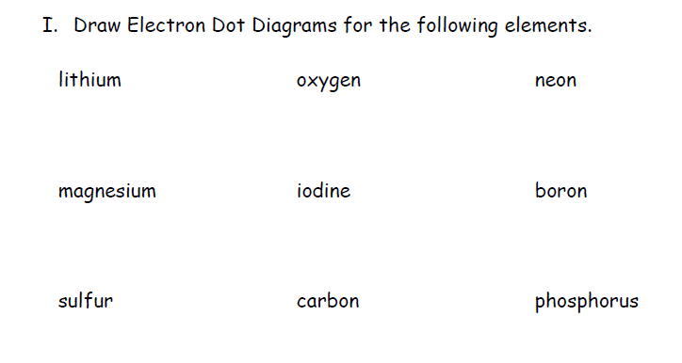

**Practice with Dot Structures**



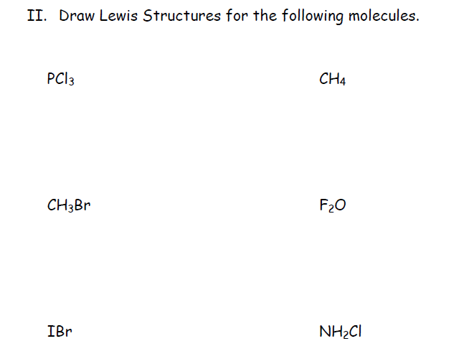



N2H2

N2H2