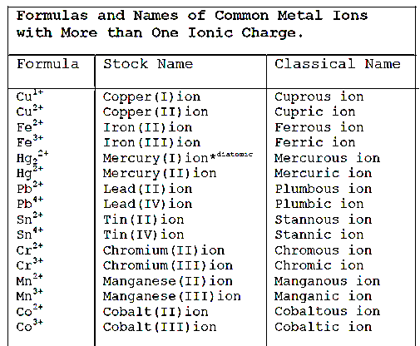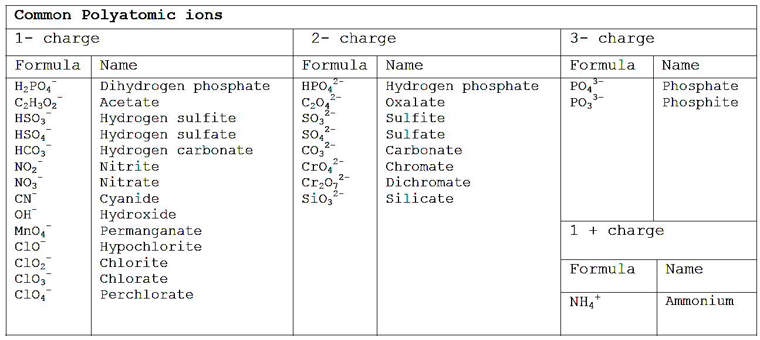

(bisulfite)

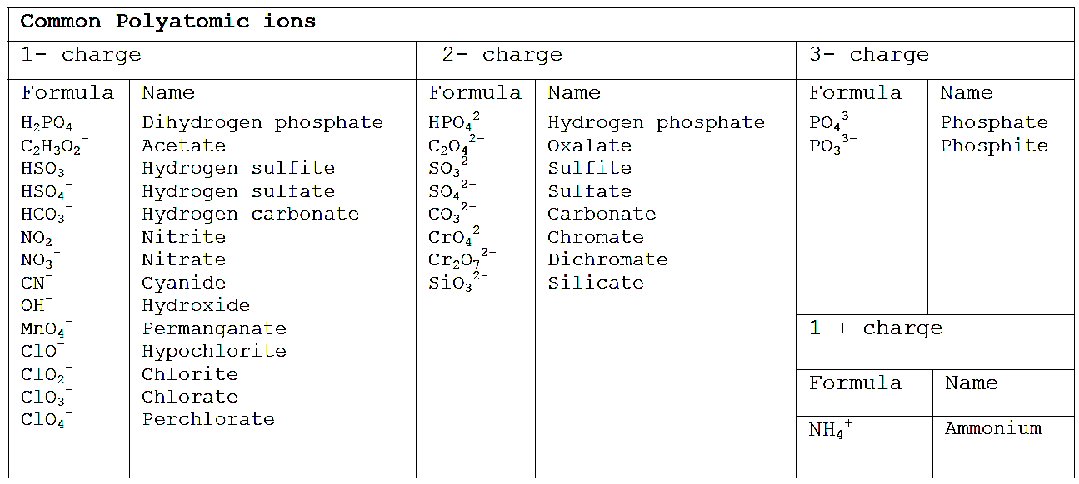

(bisulfite)

(bicarbonate)

(bisulfate)

(bicarbonate)

(bisulfate)

**Rules for Naming Ionic Compounds**

1. The cation (positively charged element) is written first in the name; the anion (negatively charged element) is written second in the name.
2. If the anion contains only one element, add the suffix –*ide* to the end
3. If the compound contains a Polyatomic Ion, use the polyatomic ion name
4. If the cation is a metal ion with a variable charge (many transition metals), the charge of the cation is written in the name using Roman numerals in parenthesis (e.g., Fe3+ = "iron(III)").

*Note: Greek prefixes are****not****used to indicate the number of atoms, or polyatomic ions, in the formula unit for the compound (e.g., Ca(NO3)2 is named "calcium nitrate" not "calciuim dinitrate").*

**Rules for Naming Ionic Compounds**

1. The cation (positively charged element) is written first in the name; the anion (negatively charged element) is written second in the name.
2. If the anion contains only one element, add the suffix –*ide* to the end
3. If the compound contains a Polyatomic Ion, use the polyatomic ion name
4. If the cation is a metal ion with a variable charge (many transition metals), the charge of the cation is written in the name using Roman numerals in parenthesis (e.g., Fe3+ = "iron(III)").

*Note: Greek prefixes are****not****used to indicate the number of atoms, or polyatomic ions, in the formula unit for the compound (e.g., Ca(NO3)2 is named "calcium nitrate" not "calciuim dinitrate").*