|  |
| --- |
| **GVC #6: I can I can understand the relationship between structure and function of organs and organ systems.** |
| **Learning Target - a.** I can relate basic plant structures to their function. |

**Plant Lab Makeup**

**p. 108-115**

**Name_______________________**

**Introduction:** Just as human bodies have organ systems that move fluids, provide nutrients, and discharge wastes, plants also have systems that perform those same functions. These systems allow plants and animals to maintain homeostasis, or a constant balance. In this activity, you will look at plants using just your eyes and also under a microscope.

1. (p. 108) What are 3 things found in plant cells that aren’t in animal cells?

2. (p. 109) What is the function of Xylem?

Draw the end of the celery stalk shown on page 109 and compare to the picture on the left:

**Label** the **Xylem** and **Phloem**

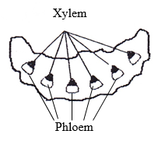 What is the function of Phloem?

Plant Organs

**ROOTS (p. 111-112)**

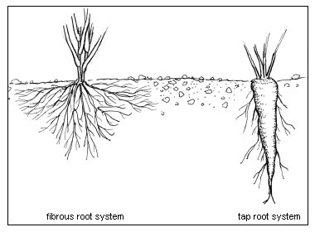3. Explain the difference in the two types of root systems.

4. What are the function of roots? (there are 3)

5. What is an advantage and disadvantage of each type of root system?

Draw the taproot and fibrous root shown on p. 111

**Tap Root Fibrous Root**

**STEMS (p. 112)**

6. What are the functions of stems? (there are 2)

**LEAVES (p. 113-114)**

Draw and label the **Stomata** on

p. 114 here, compare it to the picture below:

7. What is the primary function of leaves?

8. Explain the function of the 3 types of tissues in leaves.

Mesophyll

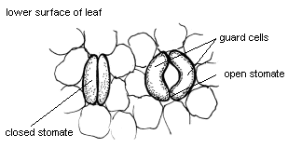 Veins

Epidermis

9. The epidermis has tiny pores called stomata.

What is the function of the stomata?

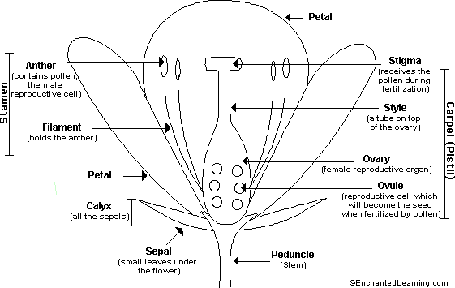**FLOWERS (p. 115)**

10. What is the function of flowers?

11. What is the name of the male and female part of the flower?

*Use the diagram to answer the following:*

Examine the flower. Use the diagram to locate the sepals and petals.

1a. How many sepals are on the flower? __________________________

1b. How many petals are on the flower?_________________

1c. Has your flower bloomed or is it closed still? _______________________

*The Stamen and the Pistil are the reproductive parts of the flower. The Stamens produce the pollen and the Pistil produces the ovules (egg cells).*

12. Locate the stamens.

2a. How many stamens are present in the flower? _____________________

13. Locate the pistil. The stigma at the top of the pistil is often sticky. The style is a long narrow structure that leads to the ovary?

3a. How many pistils does the flower have? __________________________

14. Pollen is the powdery substance at the top of the Stamens.

4a. What is the purpose of pollen? ________________________________________

15. Locate the ovary and ovules.

5a. What shape are the ovaries in? ___________________________________

5b. Which do you think produces more: pollen grains by one anther, or ovules by on ovary? Explain. __________________________________________________________