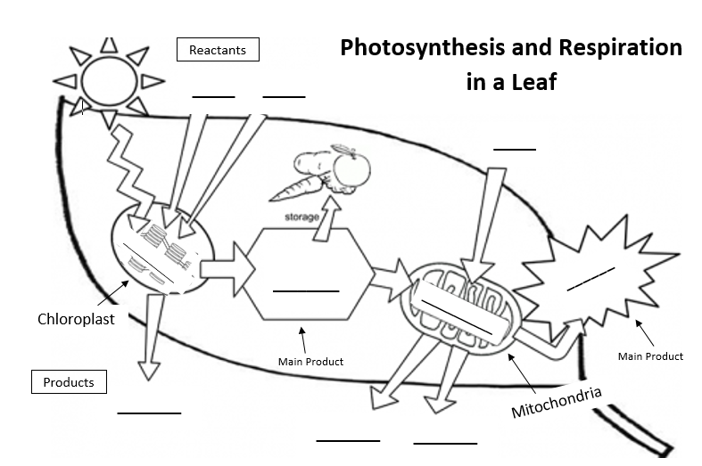

**Directions**

1. Color the Chloroplast GREEN, the Mitochondria RED, and the sun YELLOW.
2. Write the words PHOTOSYNTHESIS and RESIPIRATION on the organelles that do each process.
3. Label the main products of Photosynthesis and Respiration (SUGAR (glucose) and ATP).
4. Label the other reactants and products of Photosynthesis (WATER, CO2, O2).
5. Label the other reactants and products of Respiration (O2, WATER, CO2).

**Directions**

1. Color the Chloroplast GREEN, the Mitochondria RED, and the sun YELLOW.
2. Write the words PHOTOSYNTHESIS and RESIPIRATION on the organelles that do each process.
3. Label the main products of Photosynthesis and Respiration (SUGAR (glucose) and ATP).
4. Label the other reactants and products of Photosynthesis (WATER, CO2, O2).
5. Label the other reactants and products of Respiration (O2, WATER, CO2).