Meiosis Notes
Meiosis is like Mitosis in that it is a process of cell division. However, Meiosis does not end with the creation of 2 identical cells. Instead, Meiosis ends with the creation of 4 cells that are all genetically different. In this way Meiosis creates genetic variation and creates the sex cells of sexually reproducing organisms (egg and sperm cells).

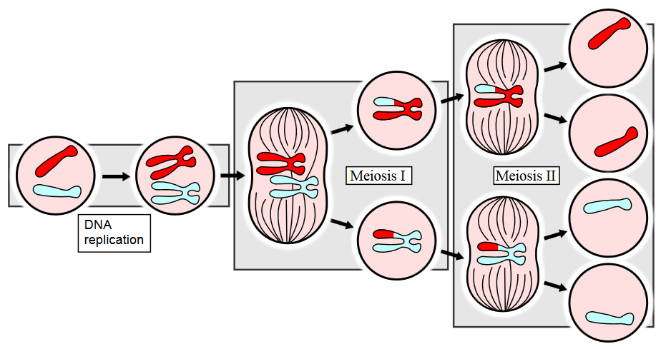

Vocabulary
Use pages 123-125 in your book to help you complete the table below

Word | Definition | How can I remember this?
Homologous Chromosome
Diploid
Haploid
Crossing Over
Allele
Gamete
Zygote

 | Mitosis | Meiosis
Number of Divisions
Number of Daughter Cells
Genetically Identical?
Chromosome #
Where
When
Function

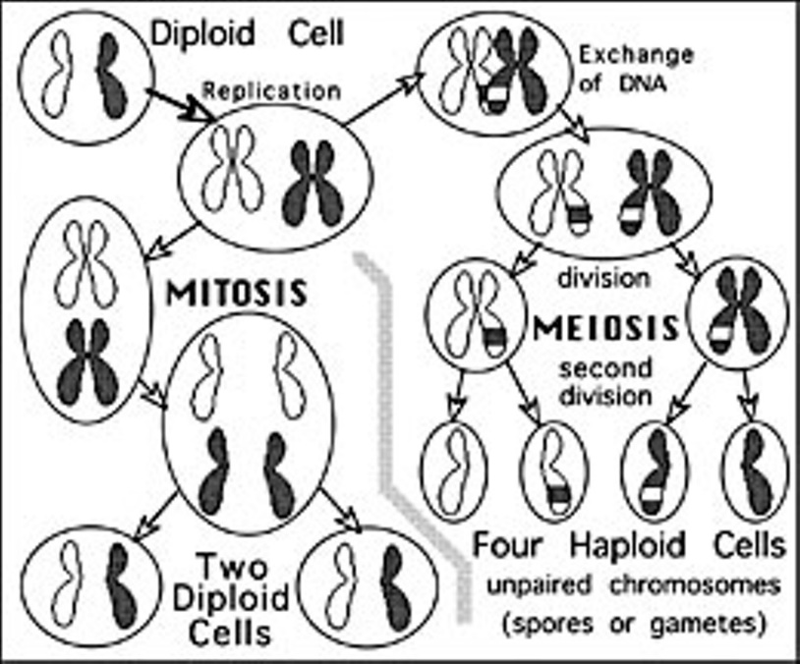
Mitosis vs. Meiosis

