WHY DO WE NEED FATS, CARBOHYDRATES, AND PROTEINS IN OUR DIET?
Biomedical Sciences
By: Patrick Brown, 3rd year PhD candidate in the Biomedical Sciences Program
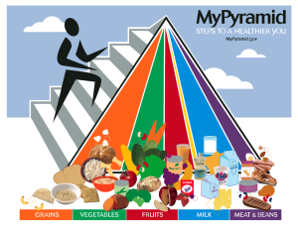
USDA
There are an endless number of diet plans available today that purport to be the answer to all of our weight loss needs.
Most of them are based on calorie restriction or minimizing intake of one of the major macromolecules found in food – fats, carbohydrates, and proteins. Probably the most famous example of this is the Atkins diet, which suggests you cut carbohydrates out of your diet and sustain yourself on protein and fat.
Although these diet systems have led to weight loss for many people, we should be careful about upsetting the balance of the macromolecules we ingest. After all, the body needs all of them to function properly.
The media may try to tell you that fat is detrimental to your health and even sell you on “fat free” foods. Fats are essential for life, however, because they perform important functions such as insulating us from the cold and providing a cushion for internal organs. Fat in the brain surrounds neurons and allows electrical signals to flow efficiently, giving us the ability to think and act quickly. At the cellular level, fats can act as information carriers and are part of the cell membrane. They are also excellent energy storage molecules. Compared to carbohydrates and proteins, fats contain twice the amount of calories per gram and can be stored for years.
Not all fats are created equal, though. More harmful fats include saturated fats and trans fats, both of which are usually solid at room temperature. Unsaturated fats are typically healthier and are liquid at room temperature, such as olive and fish oil [1]. While society may tell us that fats are bad for you, good fats are essential to life.
Carbohydrates are the body’s primary source of energy. Compared to fats they are poor molecules for energy storage and are typically used quickly after they are ingested. There are many kinds of complex sugars that can be called “carbohydrates,” but the most basic carbohydrate is glucose. Glucose is constantly being converted into ATP, which contains a large amount of energy. Cells harness energy from ATP to perform functions—anything from cellular division to sprinting on a track. When the amount of carbohydrates consumed is greater than is required for energy expenditure, it gets stored as fat for future use. Because of this, many diet plans limit carbohydrate intake in order to prevent fat accumulation.
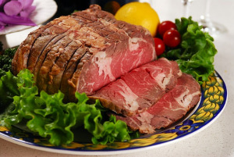
While proteins can be used as energy sources, the primary reason we need to ingest proteins is for their nitrogen. Nitrogen is necessary for building new proteins and nucleic acids. Nucleic acids (like DNA) contain our genetic information, which are the blueprints from which proteins are made. The building blocks of proteins are called amino acids. There are 21 amino acids, but our body can only produce 12 of them. The other 9, named essential amino acids, must be ingested in order to make new proteins. Proteins perform all kinds of jobs in the cell including moving molecules, signaling to neighboring cells, and replicating DNA. Unlike fats and carbohydrates, which are primarily carbon and hydrogen, all proteins contain nitrogen. In the absence of dietary protein, the body will scavenge protein from muscles to produce DNA and protein for more crucial organs of your body [2].
Currently, it is recommended that fat comprise 20-35% of an adult’s food intake, while 45-65% should be carbohydrates and 10-35% protein [3]. Each person is different, however, and only a dietary professional can tell you the macromolecule balance you need. But the next time you contemplate the latest fad diet, remember that your body requires all macromolecules to perform its best.
References:1. MayoClinic.org. Dietary fats: Know which types to choose. 2014.
2. Alberts, B., et al., Molecular Biology of The Cell. Fifth Edition ed2008, New York, NY: Garland Science, Taylor & Francis Group, LLC.
3. Otten, J.J., J.P. Hellwig, and L.D. Myers, Dietary Reference Intakes: The Essential Guide to Nutrient Requirements, 2006: Washington, D.C.

