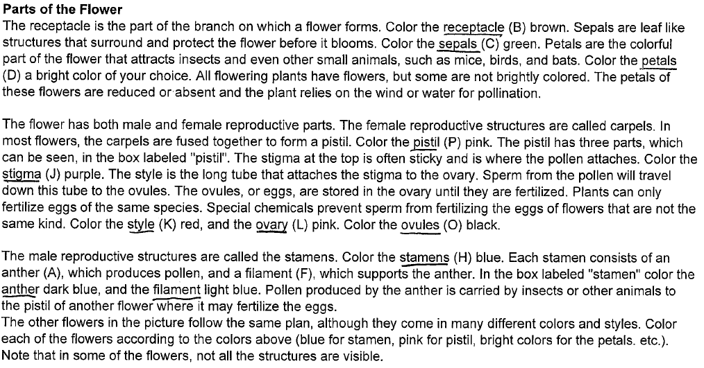
FLOWER COLORING DIRECTIONS:

AFTER COLORING THE FLOWER, USE THE READING ABOVE AND PAGE 170 IN YOUR BOOK TO DESCRIBE THE FUNCTION OF THE FOLLOWING PARTS OF A FLOWER. WRITE THESE ON THE SAME PAGE THAT YOU GLUED THE FLOWER PICTURE.

STAMEN
ANTHER
PISTIL
STIGMA
STYLE
PETALS
SEPALS
OVARY
POLLEN

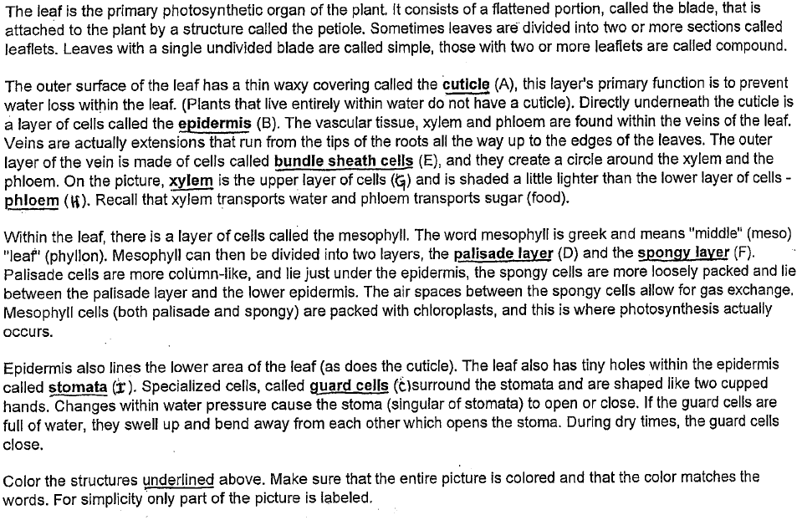
LEAF COLORING DIRECTIONS

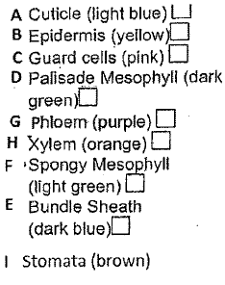
COLORING GUIDE
AFTER COLORING THE LEAF, USE THE READING ABOVE AND PAGES 162, 168-169 IN YOUR BOOK TO DESCRIBE THE FUNCTION OF THE FOLLOWING PARTS OF A LEAF. WRITE THESE ON THE SAME PAGE THAT YOU GLUED THE LEAF PICTURE.
CUTICLE
XYLEM
PHLOEM
STOMATA
GUARD CELL

