Chemistry Kinetics and Equilibrium Review
The information on this review will help prepare you for our quiz on Kinetics and Equilibrium. Use the book and your notes to find the answers to the following questions.
- Collision Theory states that reactions are the direct result of ______________ between molecules/atoms.

- In order for a collision to be “effective”, collisions between molecules or atoms must involve: (circle all that apply)

- Sufficient energy when they collide
- No products present
- A catalyst present
- Correct orientation/direction
- High pressure

- How does increasing the temperature of a reaction affect the collisions of molecules? How does it affect the rate of a reaction?

- Catalysts increase the rate of chemical reaction by what means?

- Increasing temperature
- Increasing collision energy
- Increasing concentration of reactants
- Lower activation energy

- In the following diagram, draw or label the following parts:

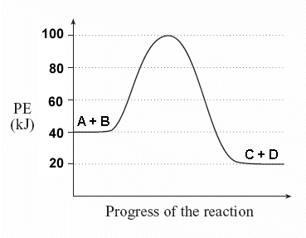
- Label the Reactants
- Label the products
- Label the transition/intermediate stage
- Indicate the activation energy required for this reaction to occur
- Draw what happens when a catalyst is introduced

- Which of the following will MOST DEFINITELY slow down the rate of a chemical reaction (circle all that apply)?

- Increasing the temperature
- Increasing the pressure
- Adding a catalyst
- Decreasing the concentration of reactants
- Decreasing the temperature

- For the following reaction, explain if energy is absorbed or released AND whether this reaction is endothermic or exothermic.
2HCl + Mg ↔ MgCl₂ + H₂ + heat

- The forward reaction depicted in this diagram is (circle all that apply): Endothermic or Exothermic? Will the reaction get warmer or colder to the touch? (Circle the correct answers). Draw what would happen if a catalyst were introduced. If heat is added to the reaction it will drive it towards the Forward or Reverse reaction.
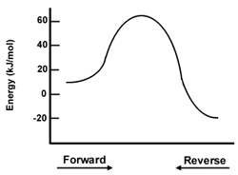

True/False: Classify each of these statements as true or false.
_______ 9. The concentrations of reactants and products in a system at dynamic equilibrium are always
changing.

_______10. A change in the pressure on a reaction only including liquids, can cause a shift in the equilibrium.

_______11. For a chemical equilibrium to be established, the concentration of reactants and products must be equal.

_______12. When equilibrium is reached, the forward and reverse reactions take place at equal rates.

- For which reaction will an increase in pressure affect the equilibrium position? How will the position change and WHY?
- H₂ (g) + F₂ (g) ↔ 2HF (g)
- SO₂ (g) + NO₂ (g) ↔ NO (g) + SO₃ (g)
- 2H₂O (g) ↔ 2H₂ (g) + O₂ (g)
- 2HgO (s) ↔ 2Hg (l) + O₂ (g)

- Use the equation below to answer the following questions:
3H₂ (g) + N₂ (g) ↔ 2NH₃ (g) ∆H = -92kJ
- Which direction would the equilibrium shift if extra NH₃ is added? _____________
- Which direction would the equilibrium shift if the pressure decreased? ______________
- What could you do to this reaction to “force” the equilibrium to produce more NH₃?

- Use the equation listed below to answer the following questions:
2 HCl(aq) + Mg(s) <--> MgCl₂(aq) + H₂(g) + heat
- When the temperature is increased, which direction would the equilibrium shift? ______________
- What would happen if hydrochloric acid (HCl) were removed? ______________________________
- Which direction would the equilibrium shift if hydrogen gas (H₂) was added? __________________
- What could you do to this reaction if you were trying to produce as much solid Magnesium (Mg)?

- Use the equation listed below to answer the following questions:
4HCl (g) + O₂ (g) ↔ 2Cl₂ (g) + 2H₂O (g)
- What would be the effect on the equilibrium position if the volume is decreased? __________________
- What direction would the equilibrium favor if you had an excess amount of O₂? ___________________

