GVC #1 -- I can explain the basic chemistry, structure and function of cells.
Learning Target - a. I can categorize the major elements utilized in cells and how they bond to form molecules.
BOOK NOTES
Pages 36-37
1. What is Matter?

2. What is an element?

3. What are the 6 most abundant elements in cells? (you can use the acronym)

4. Color those 6 elements yellow on the periodic on the backside of this paper.

5. What is a trace element?

6. On the periodic table color the following trace elements orange: Iodine (I), Potassium (K), Calcium (Ca), Iron (Fe), Magnesium (Mg), Sodium (Na) and Chlorine (Cl).

7. What is an atom?

8. Give the 3 parts of an atom and where each is located in the atom.

9. What is a chemical compound?

10. Explain the difference in ionic and covalent bonding.

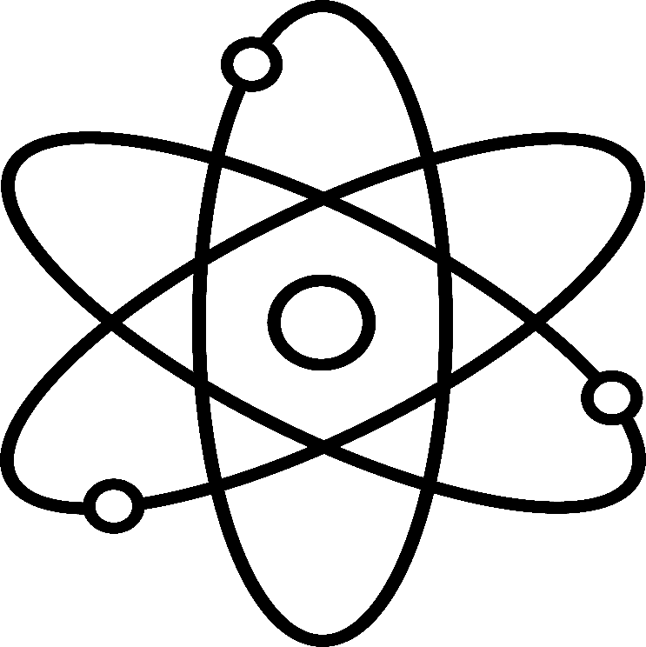
11. To the right is a picture of a Lithium atom. It has 3 protons, 4 neutrons and 3 electrons. Color it according to this key:
Protons – Red
-
Neutrons – Blue
Electrons - Green

Sooner or later every one of us breathes an atom that has been breathed before by anyone you can think of who has lived before us- Michelangelo or George Washington or Moses.
Jacob Bronowski

-

-

