Frog Dissection Makeup Lab

- Go to the Virtual Frog dissection website at http://tinyurl.com/aa4f7k.
- Click on “Introduction” and then go to “Natural History”. Use the information to answer the questions below.
- Next, click on “External Anatomy” and then click on Skin, Head, Cloaca, and Legs. Use the information given to answer the questions below.
- Use the “Menu” link at the bottom to return to the home page.
- Click on “Internal Anatomy” and do the virtual dissection. Answer the questions below and label the parts of the frog on the back of this paper.

Natural History Questions
- List the classification of the frog
Kingdom___________________
Phylum ____________________
Subphylum _________________
Class ______________________
- Why are frogs said to have “two lives”?

- List the ways in which tadpoles (immature frogs) and frogs differ from each other.

External Anatomy Questions

- Describe the coloring of the Leopard Frog. How does this coloring help the frog?

- What important process is a frog’s skin used for?

- What are the membranes to the sides of the eyes? What are they used for?

- What is a cloaca?

Internal Anatomy Questions

- How is the tongue attached to the lower jaw? How is this different than a human tongue?

- What is the largest organ in a frog?

- How many chambers does a frog heart have? How is this different than a human heart?

- What are fat bodies used for?

- Why do you think the muscles in a frog’s legs are so large?

Label the structures of the frog on the backside of this paper.

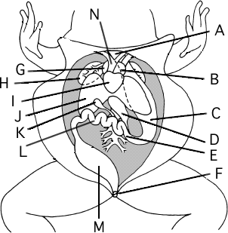
Labeling - Label the structures on the frog

A. ______________________________
B. _____________________________
C. _____________________________
D. _____________________________
E. _____________________________
F. _____________________________
G. _____________________________
H. _____________________________
I. ______________________________
J. ______________________________
K. _____________________________
L. ______________________________
M. _____________________________
N. ______________________________

