GVC #5: I can cite evidence that supports biological evolution over time and describe how this relates to the classification of organisms.
Learning Target - c. I can analyze information that supports evolution
Evidence for Evolution Book Notes
p. 158-161, 168-172
Background:
Scientific theories are powerful explanations of the natural world that are strongly supported by many lines of evidence. They have been repeatedly tested using the scientific method and confirmed through extensive observation and experimentation. Today, much evidence has been found to indicate that living things have evolved or changed gradually during their natural history. Below are some of the many lines of evidence for the Theory of Evolution.

Part 1: Age of the Earth (p. 158-161)
- How old is the Earth?

- How long has there been life on Earth?

Part 2: Fossils (p. 159-161)
Fossils are the preserved remains or traces of organisms that lived long ago. Fossils can provide clear evidence that evolution has occurred because we can see in a fossil record how a species has evolved over time.

Here is a series of skulls and front leg fossils of organisms believed to be ancestors of the modern-day horse. The earliest fossils are on the left and the most recent are at on the right.
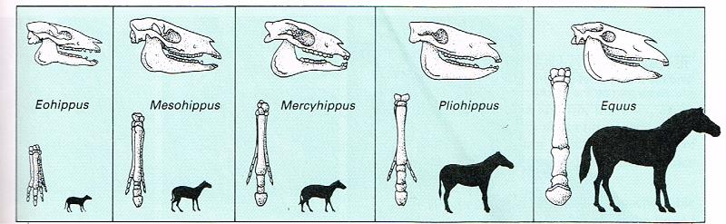
3. Look at the fossils. Give two similarities between each of the skulls that might lead to the conclusion that these are all related species.

4. What is the biggest change in leg appearance that occurred from the early horse to the modern horse?

Part 3: Comparative Anatomy - Homologous Structures (p. 168-169)
These bones are formed in similar ways during embryonic development and share similar arrangements. However they have somewhat different forms and functions. They are homologous structures.
Carefully examine the drawings of the bones shown. Look for similarities among the various animals.

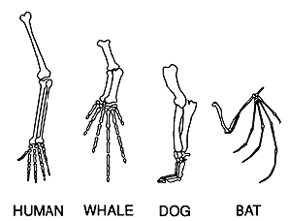
5. Describe the function of each set of bones below:
Animal | Function
Human
Whale
Dog
Bat

Part 4: Comparative Anatomy - Analogous Structures (p. 169)
Some apparently unrelated animals have organs with similar functions, yet are very different in structure and form. These structures are called Analogous Structures.
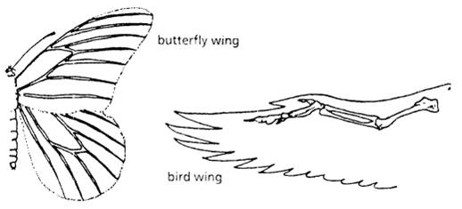
6. What is the function of each of these structures?

7. How does the form of the structures differ?

Part 5: Embryology (p. 169-170)
Organism | Similarities in Early Development | Description of change
Organisms that are closely related may also have physical similarities before they are even born. Take a look at the six different embryos below.
8. Choose 3 organisms below and fill in the table by describing how the embryos are similar in the early stage and how they change in the advanced stage.
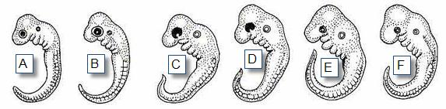
Early Stage:

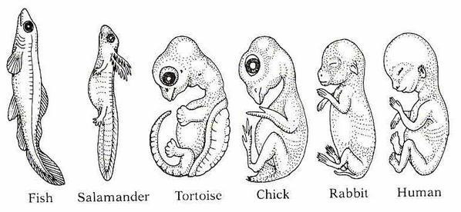
Most advanced stage, shortly before birth:
F
E
D
C
B
A

9. Explain how these embryos can be used as evidence of a common ancestor between these organisms.

Part 6: Comparative Anatomy - Vestigial Structures (p. 170)
Organs or structures that have lost their function in the organism and become reduced in size (because of efficiency) are called Vestigial Structures.
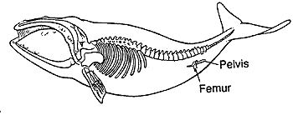
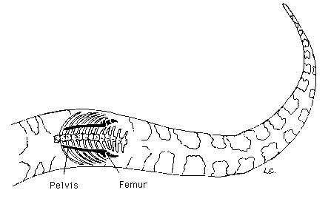
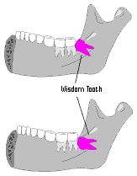
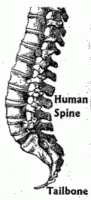

Whale pelvis and
femur (leg bone)
Human Wisdom Teeth
Snake Pelvis and
Femur (leg bone)
Human Tailbone

10. Choose two of the vestigial structures shown above and describe what purpose that structure may have had in the past.

11. How do vestigial structures provide evidence for evolution?

Part 7: Final Analysis
12. What do you think are the two most powerful evidences for evolution? Explain why you chose them.

