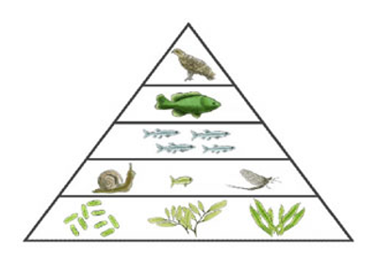

- There are more _________________ than primary consumers.
- Organisms that eat other organisms are __________________.
- Organisms that make their own food are _________________.
- Grass is considered a _____________________.
- A zebra (grass eaters) would be considered a _________________.
- Lions (zebra eaters) would be considered a _________________.
- If there is 12,345 kcal of energy available to the produces, how much will be available to the primary consumers?

  - How much will be available to the secondary consumers?
  - How about the tertiary consumers?

- There are more _________________ than primary consumers.
- Organisms that eat other organisms are __________________.
- Organisms that make their own food are _________________.
- Grass is considered a _____________________.
- A zebra (grass eaters) would be considered a _________________.
- Lions (zebra eaters) would be considered a _________________.
- If there is 12,345 kcal of energy available to the produces, how much will be available to the primary consumers?

  - How much will be available to the secondary consumers?
  - How about the tertiary consumers?

