GVC #6: I can understand how energy flows, how matter cycles, and how organisms interact in an ecosystem.
Learning Target - a. I can use an energy pyramid and food chain to analyze how energy flows in an ecosystem.
Ecology Book Notes
(Pages 4 –13)
1. Define the following terms
- Ecology
- Ecosystems
- Abiotic Factors
- Biotic Factors
2. What are the levels of ecological organization? Describe from the smallest to the largest.

3. Explain the difference in a producer and a consumer.

4. How are food chains and food webs the same? How are they different?

5. Make a food chain with 4 levels.

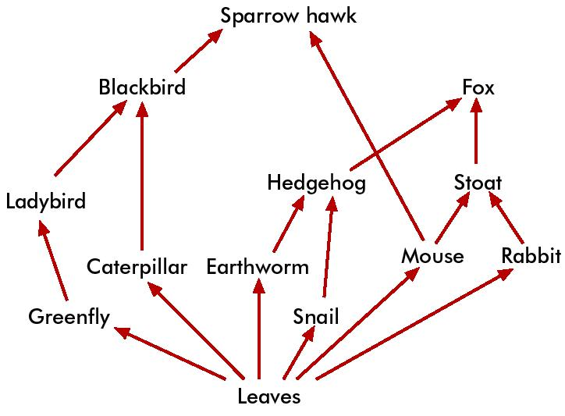
6. Using the food web to the right, construct two food chains.

7. What is the producer for this food web?

8. Name 3 consumers in the food web.

9. How much energy is transferred from one level to the next in an energy pyramid?

10. When energy is transferred, there is also a loss of energy. What form of energy is lost?

11. If it took the same amount of energy to chase a mouse as it did to chase a rat, which do you think a cat would choose to chase? Why?

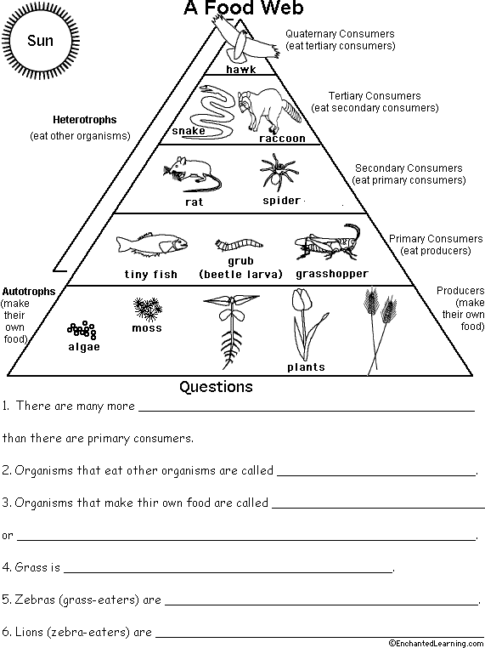

7.If there is 12,345 kcal of energy available to the producers, how much will be available to the primary consumers? ___________ How much will be available to the secondary consumers? _________________How about the tertiary consumers? ___________________
8. What is an example of a strategy used to balance the energy an organisms has to use to obtain food with energy it gains from the food?

