Ecology Book Assignment (Pages 14 –24)
1. Define the following terms
- Ecology
- Ecosystems
- Abiotic Factors
- Biotic Factors
2. What are the levels of ecological organization? Describe from the smallest to the largest.

3. Explain the difference in a producer and a consumer.

4. How are food chains and food webs the same? How are they different?

5. Make a food chain with 4 levels.

6. Using the food web to the right, construct two food chains.

7. What is the producer for this food web?

8. Name 3 consumers in the food web.

9. How much energy is transferred from one level to the next in an energy pyramid?

10. When energy is transferred, there is also a loss of energy. What form of energy is lost?

11. If it took the same amount of energy to chase a mouse as it did to chase a rat, which do you think a cat would choose to chase? Why?

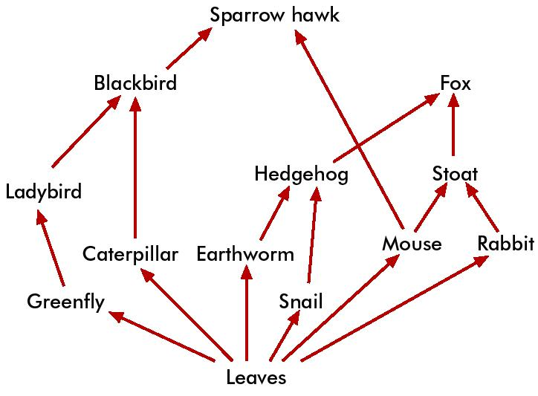

ENERGY PYRAMID

1. There are more ____________ than there are primary consumers.
2. Organisms that eat other organisms are ____________.
3. Organisms that make their own food are _________________.
4. Grass is considered a ____________________.
5. Zebras (grass-eaters) are ________________________.
6. Lions (zebra eaters) are a ___________________.
7. If there is 12,345 kcal of energy available to the producers, how much will be available to the primary consumers?
How much will be available to the secondary consumers?
How about the tertiary consumers?

ENERGY PYRAMID

1. There are more ____________ than there are primary consumers.
2. Organisms that eat other organisms are ____________.
3. Organisms that make their own food are _________________.
4. Grass is considered a ____________________.
5. Zebras (grass-eaters) are ________________________.
6. Lions (zebra eaters) are a ___________________.
7. If there is 12,345 kcal of energy available to the producers, how much will be available to the primary consumers?
How much will be available to the secondary consumers?
How about the tertiary consumers?

