GVC #3—I can identify and explain how the structure of DNA relates to its function.
Learning Target - a. I can construct a model to describe the structure of DNA
Learning Target - b. I can connect principles of DNA replication to the overall function of DNA

DNA Structure
- The structure of DNA was published by _____________ and ____________ in the year __________.
- What do the letters DNA stand for?

_____________________________________________________________

- Where is DNA found? __________________________________________

- Building Block of DNA: _______________________________

- What are the 3 things that make up a nucleotide? _________ _________ _______

- Match the bases: Adenine - _______________ and Guanine - _______________

- The double coiled, “staircase” shape of DNA is called a __________________.

- Directions: Label the diagram below with the following choices:

- Nucleotide | - Deoxyribose | - Phosphate group
- Base pair | - Hydrogen bond | - Nitrogenous base

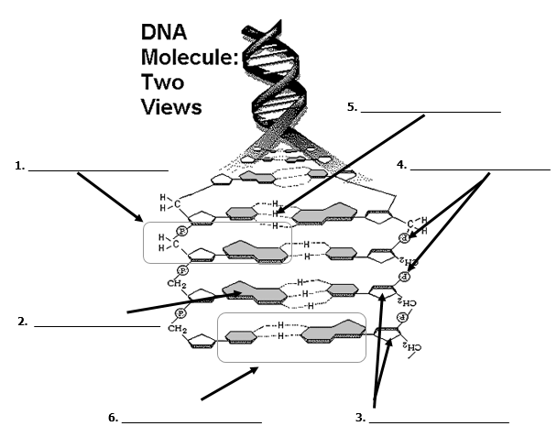

Replication (copying the DNA)

- The process of __________________ produces a new copy of an organism’s genetic information, which is passed on to a new cell.

- Create a matching (complementary) DNA sequence for the following strand:

- List the 3 basic steps of DNA replication in order:

- _________________________________________________________________

- _________________________________________________________________

- _________________________________________________________________

- Why do cells have to replicate (copy) DNA?

REPLICATION MUTATIONS
Mutations happen when the sequence of bases in the DNA gets changed. Mutations can be caused by mistakes in reading the DNA and can also be caused by environmental factors such as radiation, UV rays from the sun, or smoking.
A | T
T | A
C | G
C | G
G | C
T | A
G | C
Original
19. The model of DNA below is ready to be copied. The copied strands are shown below, the sections that came from the original strand are shaded. Compared to the original double helix, evaluate the copies made during DNA replication. If errors occurred, circle the errors and describe the problem(s) on
the lines below:

Replicated Strands
List problems if any:
_______________________
_______________________
_______________________
_______________________
_______________________
_______________________

A | T |  | A | T
T | A |  | T | A
C | T |  | C | G
C | G | AND | A | G
G | C |  | G | C
T | A |  | G | A
G | C |  | G | C

