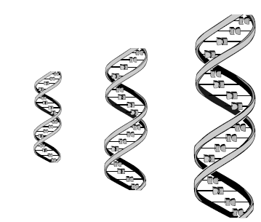
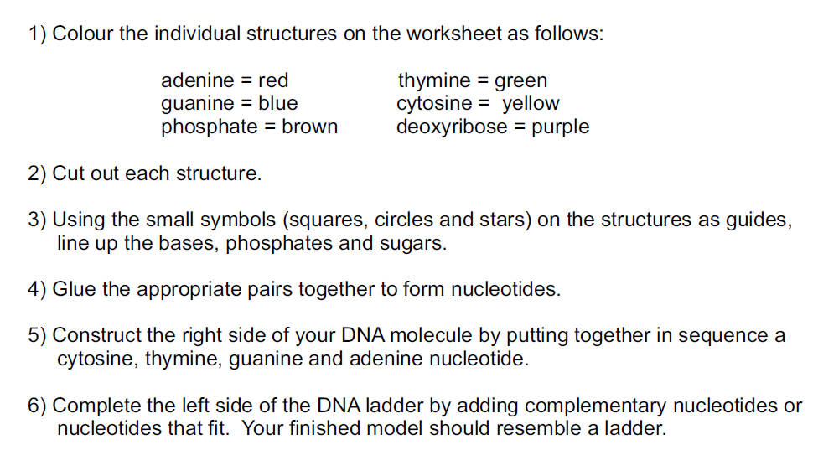
Making a Model of DNA – Instructions

*Use the DNA diagram on the back of this paper if you need a guide.

7) Once your model is complete, make a pocket in your notebook by following the example in the teacher’s notebook. Keep your model in this pocket.

8) Answer the 4 questions and glue them in your notebook on the same page as the pocket for the model.

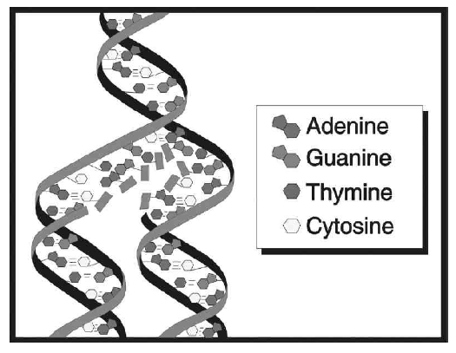
9) After completing the model and questions, each person needs to get 2 pieces of licorice, 7 toothpicks and enough marshmallows to create a DNA double helix with the following base pair order on one side: A G C G T T A and the matching base pair on the other.

Use the following color code
for the marshmallows:

Adenine: Yellow
Guanine: Orange
Thymine: Green
Cytosine: Pink

DNA Model
- When making the DNA model, what did you notice about the orientation of the two strands?

- What would be the base pair order of the strand that bonds with the strand below:
T G G A C C A T A G C

- Would you expect the DNA of a Salmon to be more similar to the DNA of a goldfish or a bear? Why?

- How would the DNA of a butterfly be different than the butterfly of a human?

DNA Model
1. When making the DNA model, what did you notice about the orientation of the two strands?

2. What would be the base pair order of the strand that bonds with the strand below:
T G G A C C A T A G C

3. Would you expect the DNA of a Salmon to be more similar to the DNA of a goldfish or a bear? Why?

4. How would the DNA of a butterfly be different than the butterfly of a human?
DNA Model
1. When making the DNA model, what did you notice about the orientation of the two strands?

2. What would be the base pair order of the strand that bonds with the strand below:
T G G A C C A T A G C

3. Would you expect the DNA of a Salmon to be more similar to the DNA of a goldfish or a bear? Why?

4. How would the DNA of a butterfly be different than the butterfly of a human?

DNA Model
1. When making the DNA model, what did you notice about the orientation of the two strands?

2. What would be the base pair order of the strand that bonds with the strand below:
T G G A C C A T A G C

3. Would you expect the DNA of a Salmon to be more similar to the DNA of a goldfish or a bear? Why?

- How would the DNA of a butterfly be different than the butterfly of a human?

