Concentration and Equilibrium Test Review
Section 1: Concentration and Dilution
- What would the molarity of a solution prepared with 1.2 moles of calcium chloride in 750 mL of water?

- What is the molarity of a solution that is prepared with 70 grams of KOH dissolved in 500 mL of water?

- If you needed to dilute concentrated (18M) sulfuric acid down to a 350mL solution that is .25M, how much of the concentrated sulfuric acid would you need to start with?

Section 2: Colligative Properties
Make sure you are familiar with these terms/concepts: freezing point depression, boiling point elevation,
- Agricultural areas that produce citrus fruits such as limes, lemons and oranges have to worry about frost affecting crops. Farmers in those areas don’t start to worry about their crops until the temperatures near -3°C. Using what you know about colligative properties, explain why they don’t worry until the temperature is well below freezing.

- If you had 3 pots of water to boil and you added the following amounts of salt to each, list the pots in the order that they would boil (from first to last):
Pot 1: 25 g salt Pot 2: 32 g. salt Pot 3: 15 g. salt Pot 4: no salt

Section 3: Reversible Reactions, Equilibrium, Le Chatelier’s Principle
True/False: Classify each of these statements as true or false.
_______ 6. The concentrations of reactants and products in a system at dynamic equilibrium are always changing.

_______7. A change in the pressure on a reaction only including liquids, can cause a shift in the equilibrium.

_______8. For a chemical equilibrium to be established, the concentration of reactants and products must be equal.

_______9. When equilibrium is reached, the forward and reverse reactions take place at equal rates.
- For which reaction will an increase in pressure affect the equilibrium position? How will the position change and WHY?
- H₂ (g) + F₂ (g) ↔ 2HF (g)
- SO₂ (g) + NO₂ (g) ↔ NO (g) + SO₃ (g)
- 2H₂O (g) ↔ 2H₂ (g) + O₂ (g)
- 2HgO (s) ↔ 2Hg (l) + O₂ (g)

- Use the equation listed below to answer the following questions:
2 HCl(aq) + Mg(s) <--> MgCl₂(aq) + H₂(g) + heat
- When the temperature is increased, which direction would the equilibrium shift? ______________
- What would happen if hydrochloric acid (HCl) were removed? _______________________
- Which direction would the equilibrium shift if hydrogen gas (H₂) was added? ___________
- What could you do to this reaction if you were trying to produce as much solid Magnesium (Mg)?

- Use the equation listed below to answer the following questions:
4HCl (g) + O₂ (g) ↔ 2Cl₂ (g) + 2H₂O (g)
- What would be the effect on the equilibrium position if the volume is decreased? __________________
- What direction would the equilibrium favor if you had an excess amount of O₂? ___________________

Section 4: Endothermic and Exothermic Review
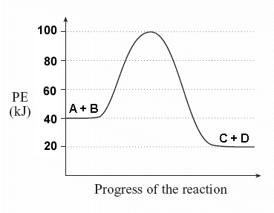
- In the following diagram, draw or label the following parts:

- Label the Reactants
- Label the products
- Label the transition/intermediate stage
- Indicate the activation energy required for this reaction to occur
- Draw what happens when a catalyst is introduced

14. For the following reaction, explain if energy is absorbed or released in the forward reaction AND whether the forward reaction is endothermic or exothermic.
2HCl + Mg ↔ MgCl₂ + H₂ + heat

