GVC #5—Cite evidence that supports biological evolution over time and describe how this relates to the classification of organisms.
Learning Target - b. I can classify organisms based on evolutionary relationships.

Part 1 - Taxonomy: Life's Filing System - Crash Course Biology Video

- What is Taxonomy?

- The trick of taxonomy is basically figuring out what?

- Who is the Swedish scientist that developed this more ordered classification system?

- Although taxonomy has come a long way since Linnaeus, we are still using the same taxa groups to classify. List these groups below:
BROADEST: MOST INCLUSIVE
SPECIFIC: LEAST INCLUSIVE
_________________________________
__________________________________________________________________
_________________________________
_________________________________
_________________________________
_________________________________

- What are the 2 names used in an organisms scientific name?

- Now that we have new technology and can classify using genetic analysis and structure, we have stuck a new taxa above Linnaeus’s kingdom. What is this more broad taxa called?

- What are the 3 domains?

1.
2.
3.

- Under the domain Eukarya, there are 4 kingdoms. List the 4 Eukaryotic Kingdoms:

1.
2.
3.
4.

PART 2 – TAXONOMIC RELATIONSHIPS - Use this chart to answer questions 1-6 below.

TAXON | House Cat | Red Fox | Dog | Wolf | Gopher | Fly
Kingdom | Animalia | Animalia | Animalia | Animalia | Animalia | Animalia
Phylum | Chordata | Chordata | Chordata | Chordata | Chordata | Arthropoda
Class | Mammalia | Mammalia | Mammalia | Mammalia | Mammalia | Insecta
Order | Carnivora | Carnivora | Carnivora | Carnivora | Rodentia | Diptera
Family | Felidae | Canidae | Canidae | Canidae | Geomyidae | Muscidae
Genus | Felis | Vulpes | Canis | Canis | Thomomys | Musca
Species | domesticus | fulva | familiaris | lupus | bottae | domestica

1. Which two animals are most closely related? Explain.

2. How do you know a dog is more closely related to a red fox than a house cat?

3. Which taxon would have more species, an order or a family?

4. Which taxon includes only organisms that can successfully interbreed?

5. If two organisms belong to the same family, what other taxonomic groups do the organisms have in common?

6. Use the chart to determine what kind of animal a Vulpes velox is.

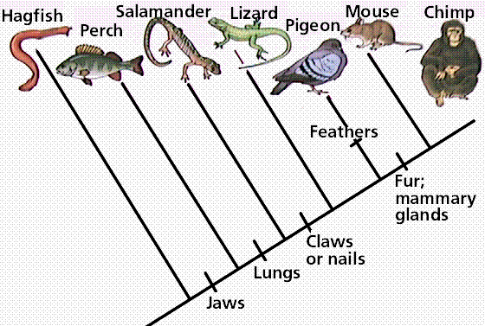PART 3 – READING A CLADOGRAM
Use the cladogram to answer questions
1-5 on part 3.

- Which animals have claws or nails?

- Which animals have jaws?

- What 3 characteristics separate perch from pigeons?

- Which characteristic(s) do salamanders and mice have in common?

- Are perch more closely related to hagfish or lizards? How do you know?

PART 4 – MAKING A CLADOGRAM
- On the cladogram below fill in the organisms below in the top boxes. Fill in the traits on the bottom boxes.
Organisms: Spider, Worm, Carpenter Ant, Fly
Trait: Cells, Legs, 6 legs*, wings
*spiders have 8 legs, ants and flies have 6 legs

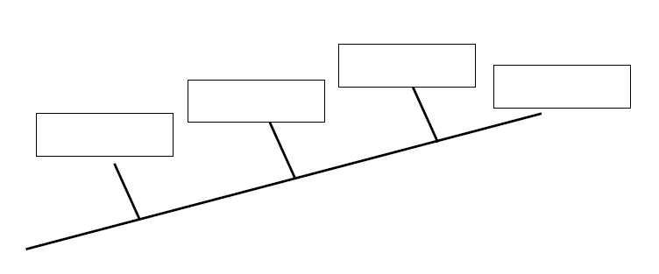
Organism:
Trait:

- According to your cladogram, are worms more closely related to spiders or ants? What evidence did you use to make your decision?

