CLADOGRAMS
Use the cladogram to answer questions 1-5 on part 3.
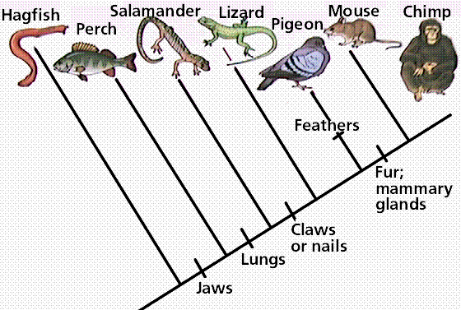

Trait:

- Which animals have claws or nails?

- Which animals have jaws?

- What 3 characteristics separate perch from pigeons?

- Which characteristic(s) do salamanders and mice have in common?

- Are perch more closely related to hagfish or lizards? How do you know?

CLADOGRAMS
Use the cladogram to answer questions 1-5 on part 3.

Trait:

- Which animals have claws or nails?

- Which animals have jaws?

- What 3 characteristics separate perch from pigeons?

- Which characteristic(s) do salamanders and mice have in common?

- Are perch more closely related to hagfish or lizards? How do you know?

MAKING A CLADOGRAM
- On the next page of your notebook, draw a larger version of the cladogram below.
- On the cladogram below fill in the organisms below in the top boxes. Fill in the traits on the bottom boxes.
Organisms: Spider, Worm, Carpenter Ant, Fly
Trait: Cells, Legs, 6 legs*, wings
*spiders have 8 legs, ants and flies have 6 legs
- According to your cladogram, are worms more closely related to spiders or ants? What evidence did you use to make your decision?
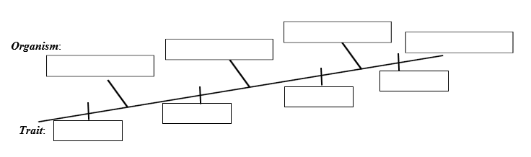

MAKING A CLADOGRAM
- On the next page of your notebook, draw a larger version of the cladogram below.
- On the cladogram below fill in the organisms below in the top boxes. Fill in the traits on the bottom boxes.
Organisms: Spider, Worm, Carpenter Ant, Fly
Trait: Cells, Legs, 6 legs*, wings
*spiders have 8 legs, ants and flies have 6 legs
- According to your cladogram, are worms more closely related to spiders or ants? What evidence did you use to make your decision?

MAKING A CLADOGRAM
- On the next page of your notebook, draw a larger version of the cladogram below.
- On the cladogram below fill in the organisms below in the top boxes. Fill in the traits on the bottom boxes.
Organisms: Spider, Worm, Carpenter Ant, Fly
Trait: Cells, Legs, 6 legs*, wings
*spiders have 8 legs, ants and flies have 6 legs
- According to your cladogram, are worms more closely related to spiders or ants? What evidence did you use to make your decision?

MAKING A CLADOGRAM
- On the next page of your notebook, draw a larger version of the cladogram below.
- On the cladogram below fill in the organisms below in the top boxes. Fill in the traits on the bottom boxes.
Organisms: Spider, Worm, Carpenter Ant, Fly
Trait: Cells, Legs, 6 legs*, wings
*spiders have 8 legs, ants and flies have 6 legs
- According to your cladogram, are worms more closely related to spiders or ants? What evidence did you use to make your decision?

