Name: _______________ Chemical Bonding (Chapter 5)
Use your books (pgs. 121-152) to fill in blanks, complete sentences or add terms to their appropriate description.
- Introduction (pgs. 121-124)
When elements form compounds, their atoms join together by sharing or transferring ___________ electrons. This creates a chemical _________.
Based on how these valence electrons interact, the physical and chemical properties of a compound will be affected and change. Fill in the table below with some of the differences between chemical and physical properties.
Physical Properties | Chemical Properties

Compounds are the result of chemical bonding. Compounds are represented by a chemical formula which indicated the type of element involved as well as the number of atoms. In the examples below, indicate the elements involved and the amount of atoms for each compound listed.
EXAMPLE: Ammonia (NH₃): Nitrogen – 1 atom, Hydrogen – 3 atoms

- Calcium chloride (CaCl₂)
- Hydrogen peroxide (H₂O₂)
- Aluminum oxide (Al₂O₃)
- Glucose (C₆H₁₂O₆)

- Valence Electrons (pgs. 126-129)
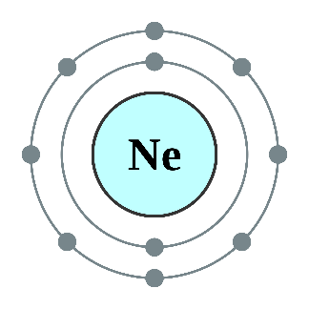
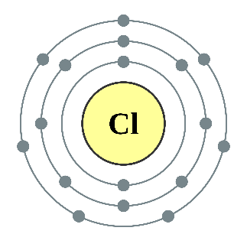
In order to be able to predict how atoms will bond, you need to understand how to predict the valence electrons for a given element. Remember that valence electrons are the ones in the outermost electron shell if we look at a Bohr diagram. Use the diagrams below to find the valence electrons for each element:
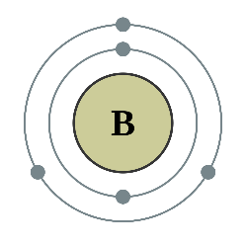
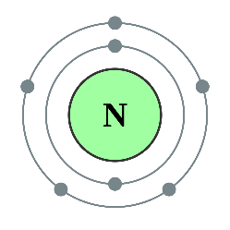

VE = _________ VE= _________
VE = _________ VE = _________

We can also represent valence electrons using dot symbols. Remember, these ONLY show valence electrons. Two dots per side for a total of 8 possible dots around a symbol. For the elements above, draw their dot symbol directly below where you wrote down their valence electrons.

Take a minute to look over the section “valence electrons and reactivity” on pg. 127. Predict which of the elements above would be relatively reactive and which would be unreactive based on their valence electrons.
Reactive: Unreactive:
- Ions (pgs. 130-134)
Up until now we’ve assumed that every atom we talk about has an equal number of protons as it does electrons. If that is the case, these atoms would be considered _____________. In all reality though, many atoms exist with an imbalance of protons and electrons. This occurs when an atoms loses or gains electrons and the atom becomes an ________.
Using information from this section, fill in the boxes with the correct descriptions of Cations and Anions.
Cations | Anions
Charge:  Electrons have been___________  Tends to include: | Charge:  Electrons have been _________  Tends to include:
**Use the periodic table on pg.133 to write the charges of ions above the groups on YOUR periodic table!
- Ionic Bonds (pgs. 135-138)
Ionic bonds form when a ___________ bonds to a _____________. In order to accomplish this kind of bond the electrons are ______________________ between the atoms in that compound. Ionic bonds are held together because _______________ charges attract.

- Metallic Bonds (pgs. 145-146)
When a metal bonds to a _______________, a metallic bond forms. This type of bond forms because ALL the valence electrons flow freely between atoms and produce what is commonly called a “sea of electrons”.

- Covalent Bonds (pgs. 149-151)
A covalent bond will form when _______________ bond to other _______________. In order to accomplish this kind of bond the electrons are ____________ between the atoms in that compound.
For the table below you will be comparing and contrasting the properties of metallic, ionic and covalent bonds. Look back on those pages listed above to place the correct terms in the boxes below.
Ionic Bonds | Metallic Bonds | Covalent Bonds
Terms to use:

- Dissolve easily in water
- Good conductors of heat
- Low boiling points
- Ductile
- Insoluble in water
- Non-electrolytes
- Malleable
- Form crystalline solids
- High melting points
- Electrolytes
- Solid at room temp
- Liquids or gas at room temp
- Good conductors of electricity
- Brittle solid

