CELLS UNIT TEST REVIEW
- Understand the three parts of the cell theory (pg 62):

- Be able to describe the differences between different cell types. Fill in the table below with information about the different cell types (pgs. 63-64, 66):
Cell type | Characteristics
Prokaryotic
Eukaryotic: Animal Cell
Eukaryotic: Plant Cell

- Make sure you understand the function of the following cell organelles (pgs. 64-66):

- Cell Membrane
- Cell wall (plant cell)
- Cytoplasm
- Ribosomes
- Mitochondria
- Chloroplasts (plant cell)
- Endoplasmic Reticulum (both smooth and rough)
- Golgi apparatus
- Lysosomes
- Vacuole
- Chromatin/chromosomes
- Nucleus
- Nucleolus
- Centrioles (animal cell)
- Flagella/Cilia (animal cell)

- Make sure you understand how the cell membrane is able to transport materials into or out of the cell (pgs. 72-75). Know the following terms or processes:
- HOMEOSTASIS
- Osmosis
- Diffusion
- Passive transport
- Facilitated diffusion
- Active transport
- Hypo-, hyper- and isotonic solutions

5. Explain the differences in photosynthesis and cellular respiration. (pages 52-57)

Practice Problems:
- Which of the following is NOT part of the cell theory?

- All living things are composed of cells
- All organisms are composed of cells
- Cells are the most basic unit of life
- Cells cannot come from pre-existing cells

- One important difference between prokaryotic and eukaryotic cells is that prokaryotic cells DO NOT have:

- Ribosomes
- DNA/RNA
- Cell membranes
- Nucleus

- Which of the following is found in plant cells but not in animal cells?

- Vacuoles b. Nucleus c. Mitochondria d. Chloroplasts

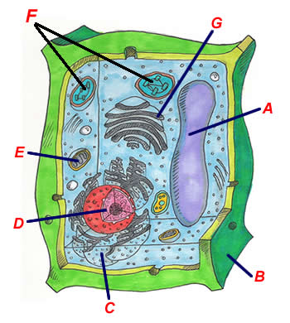
Use the diagram to the right to answer questions 4-7:

- What kind of cell is this? What about the structure of this cell
helps you to know that?

- What structure labeled has the job of producing all the
cell’s energy (ATP)?

- The structure labeled “A” has the function of:

- Converting sunlight to sugars (photosynthesis)
- Holding the cell’s DNA/RNA
- Storage
- Packages cell materials and ships them to other areas

- This structure has ribosomes on it and is also the site of other chemical reactions:

- Structure “B”
- Structure “C”
- Structure “F”
- Structure “H”

- Circle the words that correctly complete the sentence: In animals, oxygen (enters/leaves) cells while carbon dioxide (enters/leaves) the cells. Cells utilize (active transport/simple diffusion/osmosis) to move both into and out of the cells.

- ________________ transport is the process where molecules move from a low concentration to a high concentration and requires energy from the cell to take place. ________________ transport does not require energy because the molecules move from high concentration to low concentration.

- Draw the following scenarios and indicate with arrows which direction water will move:
- A plant cell placed in a high sugar solution
- An animal cell placed in a solution of pure water
- Both plant and animal cells placed in isotonic solutions

- Write the chemical formulas for both photosynthesis and respiration and explain how they are related.

- In which cell organelles do photosynthesis and cellular respiration take place?

