GVC #2—I can compare sexual and asexual reproduction, including patterns of inheritance in sexually reproducing organisms.
Learning Target – b. Compare/contrast mitosis and meiosis and their role in reproduction

Genetics Book Notes #2 – The Cell Cycle and Mitosis
Pages 67-71
Cell Cycle Coloring
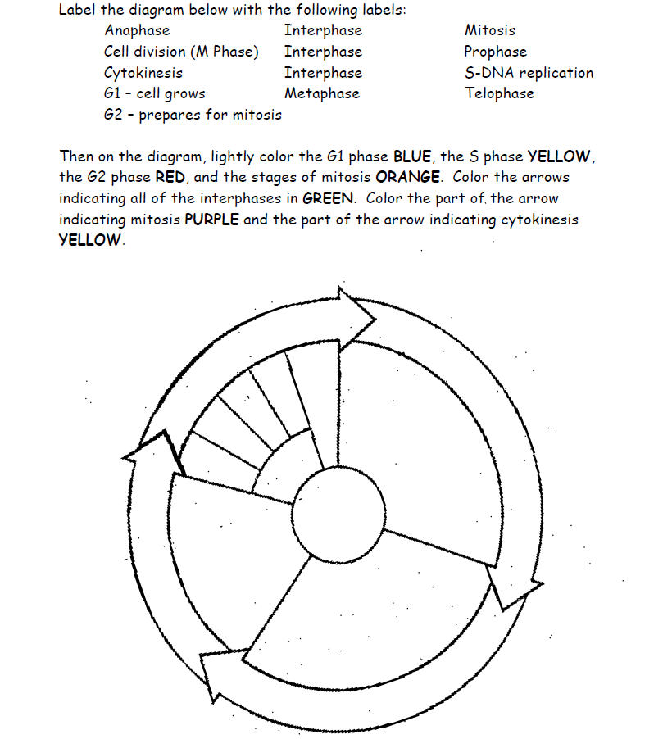
chart indicating Cytokinesis
Use pages 67-68 to answer the following questions:
