Name:___________________
Breeding Dragons

Go to www.concord.org. Scroll over “Our Projects” at the top and click on “Geniverse”. Click on “Get Started”. On the next page click “Get Started” again, then scroll down to “Geniverse Demo”. As the Demo loads the option to “Skip Intro” will appear at the very top of the screen, click on this.

Clicking “skip intro” will skip the backstory description. Essentially, the backstory is that you find a wounded dragon that you decide to take to the mystical Dragon’s Guild for healing and protection. The Dragon’s Guild does breeding experiments on Drakes (which are a lot like dragons) and they think they can use what they learn to help your dragon. However, they insist that you learn about breeding Drakes as well so you can fully be part of the Dragon’s Guild as well.

The next screen shows the training room. Click on the “Case Log” book that is sitting on the desk. This will show you the possible activities. You will complete the activities in the “Training” section.

CASE 1: ENTER THE DRAKE
Click on “Playground” (9 pts)
Four of the traits listed (metallic, wings, forelimbs, hindlimbs) are controlled by a single gene. The alleles are either Dominant or Recessive. Adjust the pull down menus on the different chromosomes and watch how this changes the appearance (phenotype) of the dragon. Determine which version of the gene is Dominant and which is Recessive. Complete the table, the first trait (metallic/non-metallic) has been done for you.
Make sure to also notice the difference between MALE and FEMALE Drakes.

 | Traits
Dominant | Metallic
Recessive | Non Metallic

Questions:
- How are male Drakes different than female Drakes ___________________________________________
- Circle all the combinations that would result in a Drake with wings:
- wings/no wings c. wings/wings
- no wings/no wings d. no wings/wings
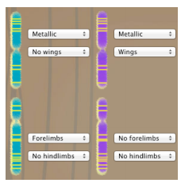
2. Circle the picture of the drake with the following allele combinations.

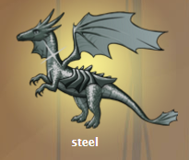
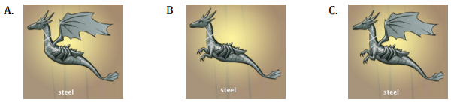

Challenge 1: Make a Drake (3 pts)
Try to make 2 drakes to match the given Drake within the amount of moves listed. Record your number of stars for each.
Drake 1: ______ Stars
Drake 2: ______ Stars

SKIP CHALLENGE 2: Good Things come in Threes

CASE 2: MY, OH SIS!
This case looks at how the gametes for the Drakes are formed during meiosis. These gametes fuse in fertilization to form baby Drakes!

Questions (3 pts)
- What is the name of the process of cell division that creates egg and sperm cells? ________
- If a single Drake cell with 6 chromosomes divided to become egg cells it would make
___________ cells, each with __________ chromosomes.

Playground
Drag at least 2 different dragons into the glowing spot, push play and watch how the chromosomes separate out in meiosis. Scroll over the chromosomes to see which traits are located on each chromosome.

Challenge 1: Making Babies (1 pts)
Try to select the gametes that will make the desired baby drakes shown at the top (if no drake is shown, click “refresh”). Drag each parent to the glowing spot. Push play in each box to create the gametes (you can speed up the process by pushing the end button).

Scroll over the chromosomes to see what traits will be inherited and select the correct 2 gametes that will produce the desired Drakes. Record the number of stars you earned. ______ Stars

SKIP CHALLENGE 2: Pick the Mommy

CASE 3: IN THE CLUTCHES OF DRAKES
Challenge 1: In the Clutches of Drakes (1 pts)
Practice changing the traits on the mom Drake so that at least one offspring will match the target drake shown at the top (click “refresh” if none are shown). Record the number of stars you earn. ______ Stars.

Challenge 4: Still in the clutches (1 pts)
Create the 2 target Drakes by changing the traits of the father. Record the number of stars you earn. ______ Stars

Oo0CASE 4: TRAITS AND MATES
Challenge 1: Settle the Argument (7 pts)
Read the 4 statements made by the 4 Trainees. Select a statement that you feel is the most correct.

- Write the statement you chose in the “claim” box below.
- Adjust the traits of the parent dragons to see how the offspring are affected.
- Use these to come up with 3 pieces of evidence to support your claim. Write them in the appropriate boxes below.
- Write at least 3 sentences in the “Reasoning” box to explain how the evidence supports your claim.
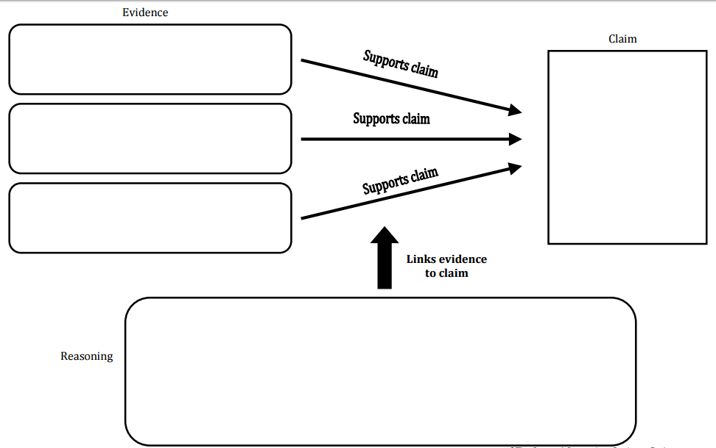

**DO CASE 5: CERTIFICATION FOR EXTRA CREDIT ON THE BACK!

EXTRA CREDIT (5 pts) – CASE 5: CERTIFICATION
For Extra Credit, take the final Trainee Certification Exam.
Record your stars: ______ Stars

Questions:
(His phenotype)
