Function of this System:

How does this function help maintain HOMEOSTAIS?

Additional Information about this system:

System Name:

Function of this System:

How does this function help maintain HOMEOSTAIS?

Additional Information about this system:

System Name:

Function of this System:

How does this function help maintain HOMEOSTAIS?

Additional Information about this system:

System Name:

Function of this System:

How does this function help maintain HOMEOSTAIS?

Additional Information about this system:

System Name:

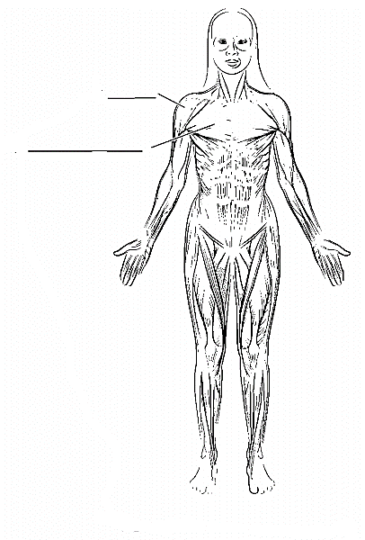
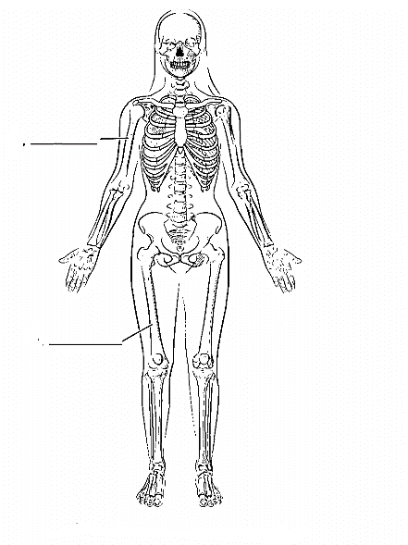
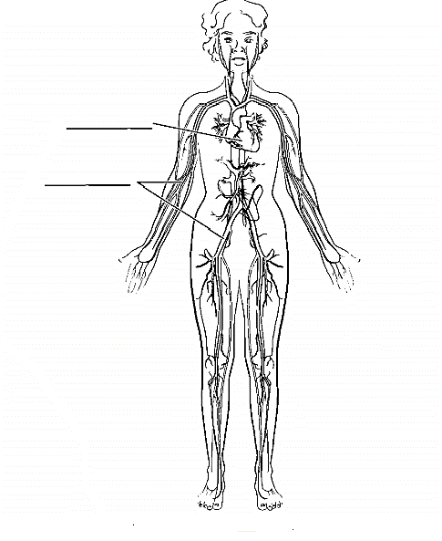
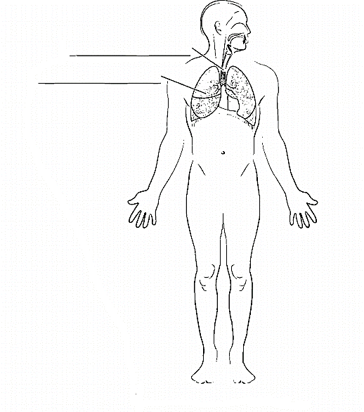

Function of this System:

How does this function help maintain HOMEOSTAIS?

Additional Information about this system:

System Name:

Function of this System:

How does this function help maintain HOMEOSTAIS?

Additional Information about this system:

System Name:

Function of this System:

How does this function help maintain HOMEOSTAIS?

Additional Information about this system:

System Name:

Function of this System:

How does this function help maintain HOMEOSTAIS?

Additional Information about this system:

System Name:







