Amoeba Sisters: Mitosis
https://www.youtube.com/watch?v=f-ldPgEfAHI
- Mitosis is a type of ________________ ____________________

- What type of cells does Mitosis produce?

- How do cells made in Mitosis resemble each other?

- In the table below write the 3 things that happen during Interphase in the “Description” section for Interphase.

- On average cells spend _______% of their time in Interphase and _______% of their time in Mitosis.

- What cell organelle contains your DNA?

- DNA are condensed into ___________________. Humans have ______ Chromosomes.

- Complete the table below for the stages of Mitosis by writing the description of each stage and drawing a picture of what the stage looks like.
Cell Cycle Stage | Description | Picture
Interphase
Mitosis:
Prophase

Mitosis:
Metaphase

Mitosis:
Anaphase

Mitosis:
Telophase

Cytokinesis

- What disease is caused by cells that are dividing out of control?
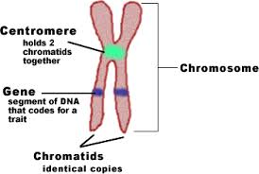
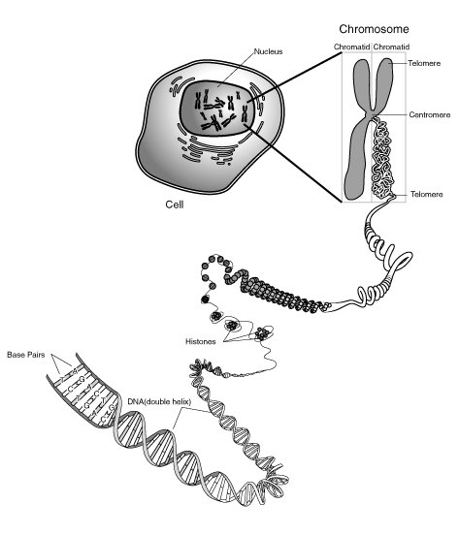
What is a Chromosome?
http://learn.genetics.utah.edu/content/basics/oldtour/

- If you stretched the DNA from a cell out, how long would it be? ___________________
- The packaging of ___________ into a chromosome is done in several steps, starting with the _________ ___________ of DNA. Then the DNA is wrapped around some proteins.
- These proteins are packed tightly together until they form a ___________. Chromosomes are efficient __________ __________ for DNA.
- What are the sex chromosomes called? _____________________________
- How many chromosomes are in
a human cell? ___________
in a mosquito? ________
a carp? _________

Structure of a Chromosome:

