GVC #4—I can describe or predict how natural selection and selective breeding lead to adaptations and biological diversity
Learning Target - c. I can draw conclusions on how the cumulative effects of adaptations lead to speciation and biological diversity.
Adaptation and Speciation Book Notes
p. 175-181
1. FORCES OF EVOLUTION (p.176-177)
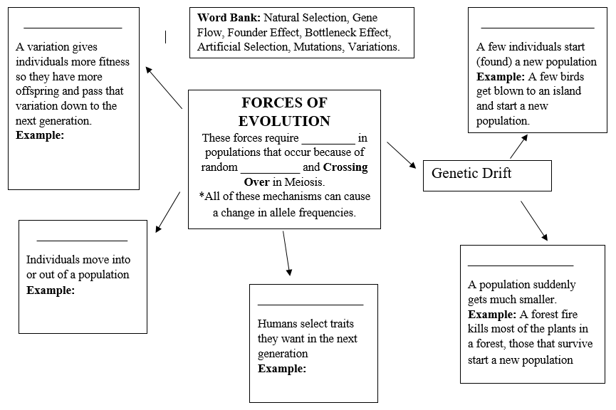

VOCABULARY: (PowerPoint or internet research)
2. Adaptations:

3. Behavioral Adaptations:

4. Structural Adaptations:

5. Co-Evolution:

6. Convergent Evolution:

7. Divergent Evolution:
SPECIATION (p. 179-180, video)
Watch the video on speciation found at http://tinyurl.com/q9qhewd and use your book to answer the questions

8. List 2 ways speciation can begin
1.

2.

9. In the bird speciation video, how many generations could it take for birds on the same island to become a different species?

10. What type of selection led to the population of birds on the opposite side of the island developing elaborate feather adaptations?

11. What are the 2 key parts of the definition of a species? (p. 179)
1.

2.

12. Define the 2 Types of speciation (p. 179-180)
Allopatric Speciation:

Sympatric Speciation:

