Notes on Acids and Bases
Pgs. 243-255
Properties of Acids and Bases (p. 243-245)
1. An Acid is a compound that produces __________________ when dissolved in __________________.

2. List 2 Properties of Acids:

3. A Base is a compound that produces ___________________ when dissolved in ________________.

4. List 2 Properties of Bases:

5. Define Indicator:

6. Litmus paper turns _____________ when dipped in an ACID and ______________ when dipped in a BASE.

7. Adding and ACID to water increases _____________, while adding a BASE to water increases ________.

8. You test an unknown solution in the lab with 3 different indicators and get the results listed below. Use the table below to determine the approximate pH of the solution.
Methyl Red – solution turns Yellow
Litmus Paper – paper turns Blue
Thymol Blue – solution turns Yellow
Indicator | pH Range | Color Change
Methyl Red | 4.8-6.0 | Red-Yellow
Litmus Paper | 5.0-8.0 | Red-Blue
Thymol Blue | 8.0-9.6 | Yellow-Blue

pH Scale (p. 246-249)
9. Label the pH Scale below with the following terms and fill in the boxes and blanks blanks:
Acid pH of pure water
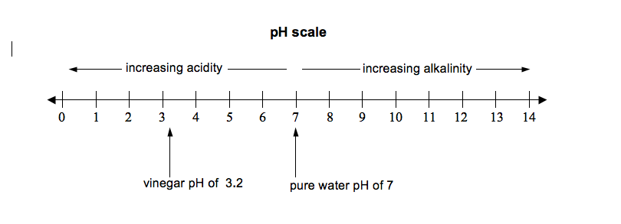
Base H⁺
Neutral OH⁻

[H⁺] < [_____]
[____] > [OH⁻]

[H⁺] = [OH⁻]

10. Fill in the blank spaces on the table below (notice the numbers are not the same as in the book):
[H+} in mol/L | [H+] in mol/L (scientific notation) | pH
0.1 |  | 1
 | 1.0 x 10⁻²
0.0001 |  | 4
0.000001
 | 1.0 x 10⁻¹¹
 |  | 14

11. The pH scale is a __________________________ scale.

12. What is the formula used to calculate pH?

13. As the concentration of Hydrogen ions [H+] increases, the pH ________________________.

14. Use the formula in #11 to calculate the pH of following solutions and decide if they are acidic, basic, or neutral.

- [H+] = 1.3 x 10⁻¹²

- [H+] = 3.0 x 10⁻³

Combining Acids and Bases (p. 251-254)
15. Define Neutralization:

16. Write the general formula for the reaction between an Acid and a Base (this is called a neutralization reaction)

17. Examples of formulas for some Acids are:

18. Examples for formulas for some Bases are:

19. All acid-base reactions also produce __________________, which are _________________ compounds.

20. What is the purpose of a Titration?

21. Describe the process of Titration.

22. Suppose you Titrate 50 mL of Hydrochloric Acid (HCl) with 30 mL of 0.4M Sodium Hydroxide (NaOH), use the formula below to calculate the concentration of the Hydrochloric Acid.
Formula: (M_{a})(V_{a})= (M_{b})(V_{b}) M_{a} = Molarity (concentration) of Acid M_{b} = Molarity (concentration) of Base
V_{a} = Volume of Acid V_{b} = Volume of Base

